# Assignment – 7

1. What is a bash shell script? Give one example. ?

Answer->

A bash shell script is a file that contains a number of commands written for the bash shell . it allows you to automate tasks by executing several bash commands , in sequence . similar to how a program operates . the script typically begins with a shebang.

* ┌──(kumya㉿sonic)-[~]

└─$ kwrite greet.sh

* First create a file called greet in which you can write content to greet.
* ┌──(kumya㉿sonic)-[~]

└─$ bash greet.sh

Hello , Kumya

Today is Sat Sep 27 10:51:03 AM +0530 2025

your current working directory is /home/Kumya

* By using bash file name we can give permission to execution and it prints the content of file on terminal.

1. Write a simple shell script to print “Hello World”. ?

Answer->

* First create a file called file.sh to write a content . you can create a file using many ways like cat command, nano command, kwrite command etc.
* ┌──(kumya㉿sonic)-[~]

└─$ kwrite file.sh

* Then you can give permission to file to execution to execute with command bash file name
* ┌──(kumya㉿sonic)-[~]

└─$ bash greet.sh

Hello World .

1. What is the purpose of comments (#) in a shell script?

Answer->

* # is used to write a comments which are required.
* #!/bin/bash
* #this script prints a greeting message
* #Author: Kumya
* #date: 27-09-2025
* echo “Hello, $USER” # prints greeting to user
* #echo “this line won’t run”

1. How do you declare variables (int, float, double, string, Boolean, and char in a shell script?

Answer->

* First create a file using kwrite command and then enter the variables, constants, Boolean and character.



* ┌──(kumya㉿sonic)-[~]

└─$ bash variables.sh

name : Kumya

age : 19

pi : 3.14

logged in: true

initial : B

1. Write a shell script to display the current date and time of the system. ?

Answer->

* ┌──(kumya㉿sonic)-[~]

└─$ echo "Current Date and Time: $(date)”



1. Explain the difference between a constant and a variable in bash script. ?

Answer->

| **Variable** | **Constant** |
| --- | --- |
| Value can change during script run | Value cannot be changes ones assigned |
| var=value | Var=value |
| mutable | immutable |
| Name=”Kumya” | Pi=3.14 |

1. Write a shell script to read two integer number from the user and compute the sum of both the

number. ?

Answer->

* First create a file named sum of 2 numbers in shell.
* ┌──(kumya㉿sonic)-[~]

└─$ kwrite sum_2_no.sh



* You can see the output of sum of two numbers.
* By running a bash file name gives output.

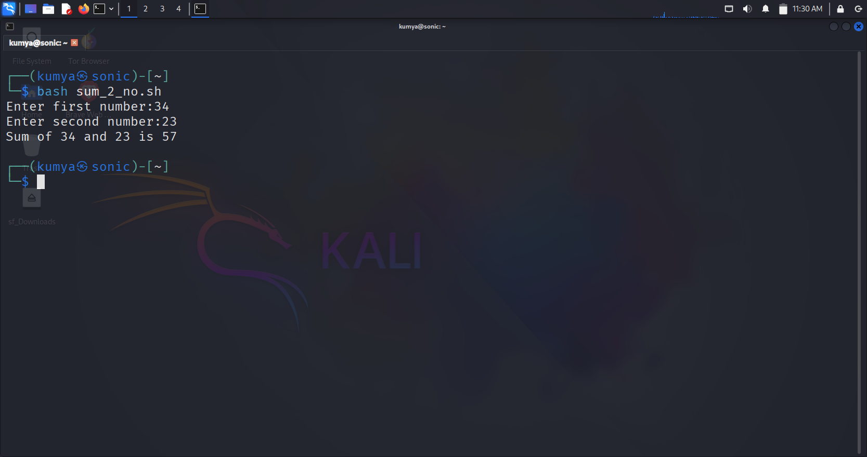

1. What is the use of source command in shell scripting ?

Answer->

* The source command runs a shell script in the current shell session versus starting a new shell . it is commonly used to load a set of environment variables, function , configure files and will persist the variables and function in the current shell
* Key points.
* Runs the script in the current shell.
* Id used to reload configure files.
* Shorthand for source is just a single dot(script.sh)

1. How can you debug a shell script? Give two methods. ?

Answer->

* Debugging help in finding error in shell script file .
* There are 2 types .
* -x and -n
* ┌──(kumya㉿sonic)-[~]

└─$ bash -x sum_2_no.sh

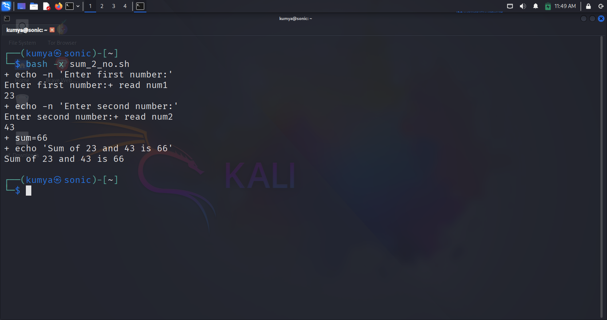

* ┌──(kumya㉿sonic)-[~]

└─$ bash -n sum_2_no.sh

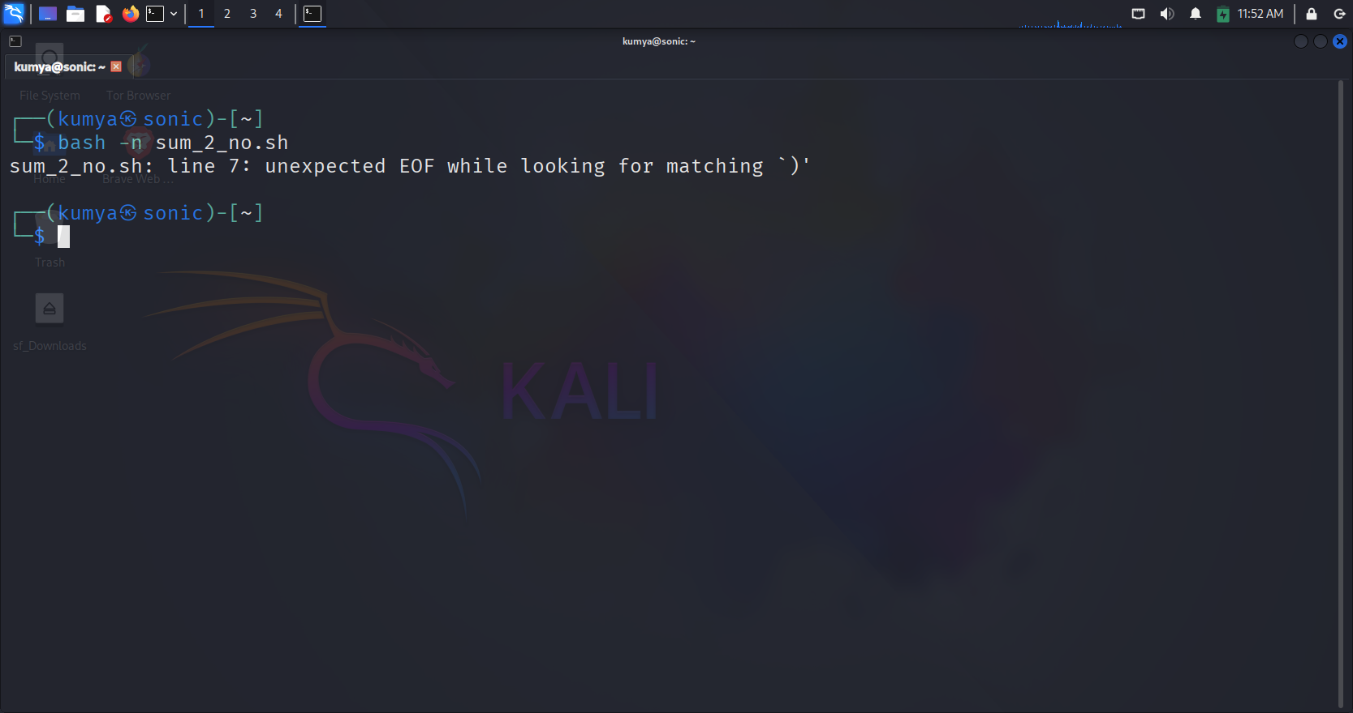

1. Write a bash script to create and delete a file ?

Answer->

* Create a file using a kwrite command.
* ┌──(kumya㉿sonic)-[~]

└─$ kwrite create_delete_file.sh

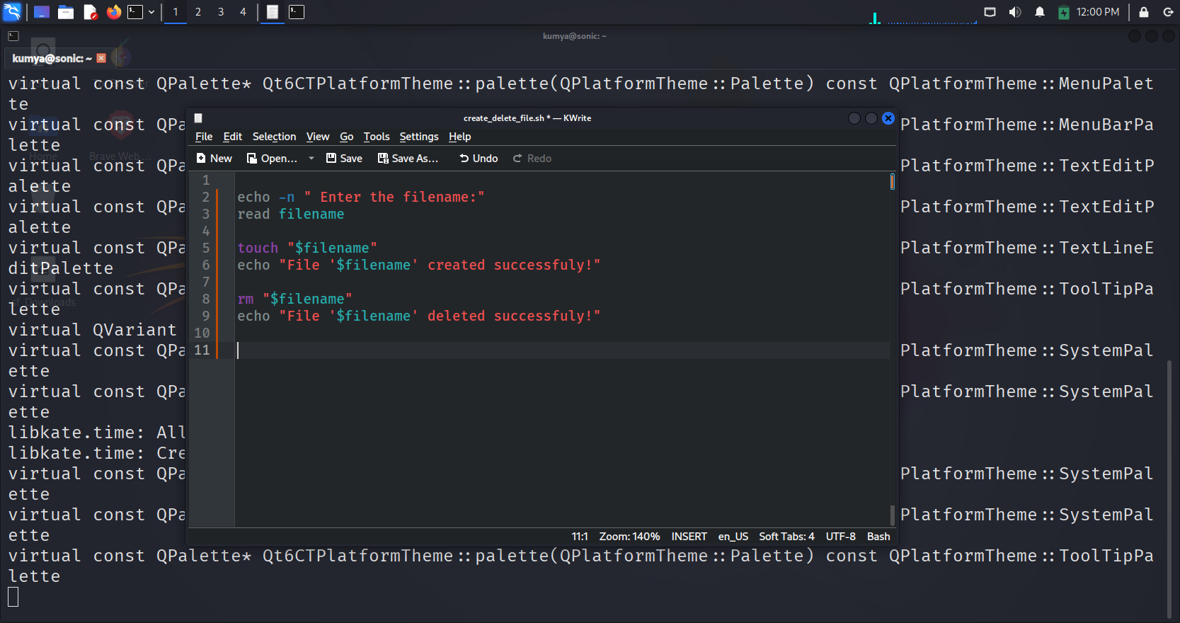

* Use a bash command to run a file .
* ┌──(kumya㉿sonic)-[~]

└─$ bash create_delete_file.sh  
